PiXL Independence:
GCSE Chemistry – Student Booklet
KS4

Atomic structure and the periodic table
Contents:
- Level 1- Multiple Choice Quiz – 20 credits
- Level 2 - 5 questions, 5 sentences, 5 words – 10 credits each
- Level 3 - Science in The News – 100 credits
- Level 4 - Scientific Poster – 100 credits
- Level 5 - Video summaries – 50 credits each

PiXL Independence – Level 1
Multiple Choice Questions
GCSE Chemistry – Atomic structure and the periodic table

INSTRUCTIONS Score: /20
- Read the question carefully.
- Circle the correct letter.
- Answer all questions
1. | The centre of an atom is called the:
 | a. | Nucleus
 | b. | Neutron
 | c. | Shell
 | d. | Centre
2. | The sub-atomic particles found in the centre of an atom are:
 | a. | Electrons and neutrons
 | b. | Protons and electrons
 | c. | Protons and neutrons
 | d. | Protons and nucleus
3. | The charge of the centre is:
 | a. | Positive
 | b. | Negative
 | c. | Neutral
 | d. | Positive and negative
4. | An isotope always has the same number of:
 | a. | Electrons
 | b. | Neutrons
 | c. | Protons
 | d. | Atoms
5. | Isotopes of an element have a different number of:
 | a. | Electrons
 | b. | Neutrons
 | c. | Protons
 | d. | Atoms
6. | Elements in the same group have:
 | a. | Different properties
 | b. | The same number of outer shell electrons
 | c. | The same number of electron shells
 | d. | The same number of protons
7. | Elements in the same period have:
 | a. | The same properties
 | b. | The same number of outer shell electrons
 | c. | The same number of electron shells
 | d. | The same number of protons
8. | Elements with the same number of outer shell electrons have:
 | a. | The same properties
 | b. | Different properties
 | c. | The same number of electron shells
9. | Mendeleev organised his periodic table by:
 | a. | Atomic number
 | b. | Proton number
 | c. | Electron number
 | d. | Atomic mass
10. | The reactivity of group 1 increases:
 | a. | As you go down the group
 | b. | As you go up the group
 | c. | It does not change
 | d. | Until potassium, then it stays the same
11. | The reactivity of group 7 increases:
 | a. | As you go down the group
 | b. | As you go up the group
 | c. | It does not change
 | d. | Until bromine then it stays the same
12. | The charge of the electron is:
 | a. | Positive
 | b. | Negative
 | c. | Neutral
 | d. | Positive and negative
13. | Group 1 metals are:
 | a. | Reactive with water and hard to cut
 | b. | Reactive with water and soft to cut
 | c. | Not reactive with water and hard to cut
 | d. | Not reactive with water and soft to cut
14. | Group 0 elements:
 | a. | Are all solids at room temperature
 | b. | Are all unreactive as they have a full outer shell of electrons
 | c. | Are all liquids at room temperature
 | d. | Are all very reactive as they have a full outer shell of electrons
15. | Group 1 and Group 7 elements reactive together because:
 | a. | They are metals and none metals
 | b. | They can transfer one electron to complete both outer shells
 | c. | They are all very reactive
 | d. | The proton numbers are compatible
16. | Properties of transition metals include:
 | a. | Strong, low melting points with a high density
 | b. | Weak, low melting points with a high density
 | c. | Strong, high melting point with a low density
 | d. | Strong, high melting point with a high density
17. | A lithium atom has:
 | a. | 3 protons, 3 electrons and 4 neutrons
 | b. | 3 protons, 4 electrons and 3 neutrons
 | c. | 3 protons, 3 electrons and 7 neutrons
 | d. | 3 protons, 7 electrons and 7 neutrons
18. | The modern periodic table is arranged by:
 | a. | Mass number
 | b. | Electron number
 | c. | Atomic mass
 | d. | Atomic number
19. | The correct word equation for lithium reacting with iodine is:
 | a. | Lithium + Iodine → Lithium iodine + water
 | b. | Lithium + Iodine → Lithium iodide
 | c. | Lithium + Iodine → Lithium iodide + water
 | d. | Lithium + Iodine → Lithium iodine
20. | The symbol equation for the reaction between lithium and iodine is:
 | a. | Li + I → LiI + H₂O
 | b. | Li + I₂ → LiI₂ + H₂O
 | c. | 2Li + I₂ → 2LiI₂
 | d. | 2Li + I₂ →2 LiI

PiXL Independence – Level 2
5 questions 5 sentences 5 words
GCSE CHEMISTRY – Atomic structure and the periodic table

INSTRUCTIONS

- For each statement, use either the suggested website or your own text book to write a 5-point summary. In examinations, answers frequently require more than 1 key word for the mark, so aim to include a few key words.
- It is important to stick to 5 sentences. It is the process of selecting the most relevant information and summarising it that will help you remember it.
- Write concisely and do not elaborate unnecessarily, it is harder to remember and revise facts from a big long paragraph.
- Finally, identify 5 key words that you may have difficulty remembering and include a brief definition. You might like to include a picture to help you remember it.

Example:
QUESTION: | Explain the reactivity in Group 1.
Sources: | Website –  - http://www.bbc.co.uk/schools/gcsebitesize/science/aqa/fundamentals/theperiodictablerev2.shtml  - http://www.s-cool.co.uk/gcse/chemistry/the-periodic-table/revise-it/group-i-and-group-ii
- The reactivity increases as you go down the group.
- They have the same number of electrons in their outer shells.
- The further down the group, the further away the electron is from the nucleus.
- Therefore, the electron is better shielded and the attraction is weaker.
- As a consequence, the electron is easier to remove.

Reactivity |  | attraction | Further away | weaker | remove
QUESTION 1: | Explain the reactivity of the Group 7 halogens.
Sources: | Website –  - https://www.youtube.com/watch?v=J7b2aBKa6-U  - hhttp://www.bbc.co.uk/education/guides/z3vwxnb/revision/4
QUESTION 2: | Describe the sub atomic particles and their arrangement in the atom.
Sources: | Website –  - https://tse2.mm.bing.net/th?id=OIP.SxZZQN5LZoRtrb4caYuIVwEsD-&w=251&h=213&c=7&qlt=90&o=4&dpr=1.5&pid=1.7  - http://chemistry.tutorcircle.com/inorganic-chemistry/atomic-structure.html
QUESTION 3: | Explain how the arrangement of the periodic table is related to the electron arrangement in atoms.
Sources: | Website –  - https://www.visionlearning.com/en/library/Chemistry/1/The-Periodic-Table-of-Elements/52  - http://www.bbc.co.uk/schools/gcsebitesize/science/add_aqa_pre_2011/atomic/atomstrucrev5.shtml
QUESTION 4: | Compare the general properties of transition metals and alkali metals.
Sources: | Website –  - http://www.gcsescience.com/pt20.htm  - http://www.gcsescience.com/pt5.htm
QUESTION 5: | Describe metals and non-metals and explain the differences between their physical and chemical properties.
Sources: | Website –  - https://www.thoughtco.com/metals-versus-nonmetals-608809  - http://www.differencebetween.com/difference-between-metals-and-nonmetals/
PiXL Independence – Level 3
Science in the News
GCSE Chemistry – Atomic structure and the periodic table
INSTRUCTIONS
Fake news
Sensationalised news stories have been around for some time, but with the mass growth of social media, the problem seems to have grown in recent years. At the very least, the US Presidential election has certainly highlighted the impact that misleading information can have. www.tiny.cc/fakenews2
At home, the Brexit vote also suffered from the circulation of misleading news stories www.tiny.cc/fakenews3
Therefore, the ability to identify real information, track it back to the source article and make your own judgement is a very important skill. This activity will help you develop that skill.

How do elements get their name?
News article: http://www.bbc.co.uk/news/science-environment-35220823
News article: http://theweek.com/articles/479682/how-new-periodic-table-elements-names
Discussion article: https://www.livescience.com/55034-new-elements-names.html

Task 1:
You need to produce a 1 page essay on how elements are named in the periodic table and how they get their position.

Essay section | Activity
Introduction | Write about how the modern periodic table is arranged.
Describe | Describe the how elements were discovered.
Explore | Why people choose the names they do?
Evaluate | Does it give the proper recognition to the correct people? Do you agree? Give both sides of the argument and then your opinion.

What is the chemistry behind hydrogen bombs?
News article: http://www.mirror.co.uk/news/uk-news/solar-flare-power-billion-hydrogen-11139984
Discussion video: http://www.independent.co.uk/news/world/asia/north-korea-latest-south-simulates-attack-nuclear-testing-sites-hydrogen-bomb-kim-jong-un-donald-a7927941.html
Real article: https://www.pcauthority.com.au/news/what-is-a-hydrogen-bomb-the-science-behind-north-koreas-test-claims-472443

Task 2:
You need to produce a 1 page essay on the background of hydrogen bombs and the actual science behind the news – how do they work? What are they made from? Are they a threat?

Essay section | Activity
Introduction | What is a hydrogen bomb and why are they relevant today?
Describe | Using a diagram, describe how the hydrogen bomb works.
Explore | Explore the chemistry concepts behind the hydrogen bomb – how does it work? Why does it create a problem for the world at large?
Evaluate | Evaluate whether countries should have hydrogen bombs. Give both sides of the argument and then your opinion.

PiXL Independence – Level 4
Scientific Posters
GCSE Chemistry – Atomic structure and the periodic table

INSTRUCTIONS
Scientific Posters
Scientists communicate research findings in three main ways. Primarily, they write journal articles much like an experiment write up. These are very concise, appraise the current literature on the problem and present findings. Scientists then share findings at conferences through talks and scientific posters. During a science degree, you would practice all three of these skills.

Scientific posters are a fine balance between being graphically interesting and attracting attention and sharing just the right amount of text to convey a detailed scientific message. They are more detailed than a talk and less detailed than a paper.
Use this information to help structure your poster – www.tiny.cc/posterskills (that’s Poster Skills not Posters Kill!) More detailed guidance is available at : www.tiny.cc/posterskills2

Creating your poster
It is easiest to create a poster in PowerPoint; however, you need to add custom text boxes rather than using the standard templates.
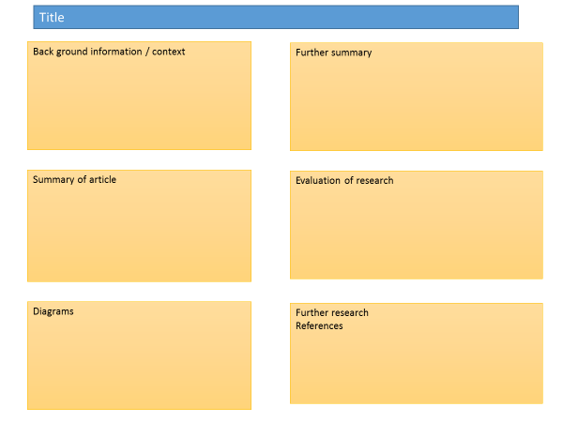
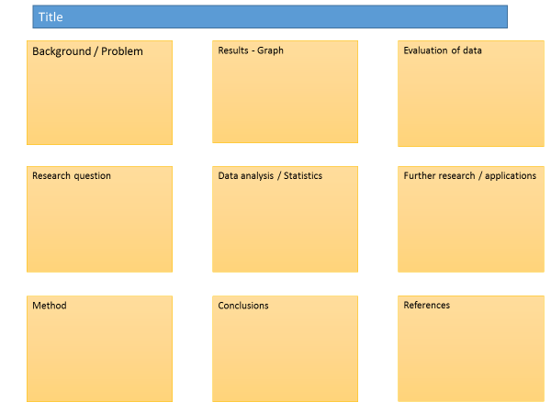

Posters need to be eye catching, but readable from a distance. If you use PowerPoint, start with a 4:3 slide (for easier printing, it can then be printed on A3) and use a 14-16 pt font. The first box could be larger to draw people in. You can use a background image, but pick a simple one that is of high quality. Select ‘text box fill’ and select ‘change the transparency’ to maintain the contrast and partially show the picture.
You can experiment with different layouts and you should include images. Avoid a chaotic layout, posters are read from top left column downwards.
Remember to include the authors and references.
Finally, look at the examples given on the University of Texas website which also offers an evaluation of each www.tinyurl.com/postereg

The Periodic Table

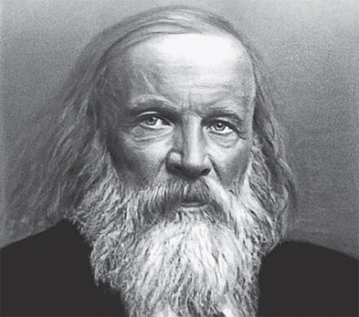

Background
When looking at the periodic table it may feel like it was organised so long ago that it is irrelevant to you. However, the methods, skills and knowledge scientists used to develop the table are relevant to many careers; from the Armed Forces to medicine.

Source articles
http://www.bbc.co.uk/schools/gcsebitesize/science/aqa/fundamentals/theperiodictablerev2.shtml
http://www.bbc.co.uk/education/guides/z3vwxnb/revision
http://www.bbc.co.uk/schools/gcsebitesize/science/add_aqa/bonding/ionic_bondingrev5.shtml
https://www.texasgateway.org/resource/arrangement-elements-periodic-table

Use other sources as necessary.

Task:
Produce a scientific poster on how the modern periodic table is arranged and the reactions and properties of Group 1 and 7. You must include the reasons they are in groups and periods, as well as why they react in the way they do.

Recall | Write a list of the properties of Group 1 and 7 elements.
Describe | Describe how the electron shells and atomic number help to place the elements in the periodic table.
Compare | Compare how the Group 1 and 7 elements react and why they do this.
Evaluate | Can these reactions help to predict how Group 2 metals and Group 0 gases may react? Include reasons for your answer.

PiXL Independence – Level 5
Video summaries
GCSE Chemistry – atomic structure and the periodic table

Cornell Notes
At A level and University, you will make large amounts of notes, but those notes are only of use if you record them in a sensible way. One system for recording notes is known as the Cornell notes system. This method encourages you to select relevant information, rather than trying to write a transcript of everything said. More importantly, it forces you to spend a few minutes reviewing what you have written, which has been scientifically proven to aid learning and memory retention.
The ideal is to write everything on one page, but some students may prefer to type and others will to handwrite their notes. Whichever option you use, remember the aim is to summarise and condense the content with a focus on the objectives that you are trying to learn and understand.

There are three main sections to the Cornell notes
- Cue/ Objectives – This can be done before or after the lecture. You may have been provided with the objectives or you may need to decide what they were or you may want to make the link to your learning if this is an additional task or lecture you are viewing, such as this video.
- Notes – In this space you record concisely, simply the things you are LESS likely remember - The NEW knowledge.
- Summary – The most important step that is carried out after the lecture or video. This helps to reinforce learning.

Background
The following short videos link to your learning. The first video takes an in depth look at 10 elements which appear to behave in an unexpected way. The second clip looks at the history behind the discovery of the elements.
Source article:

Video 1 – The Top 10 Strangest Elements
You tube clip: https://www.youtube.com/watch?v=khymS6V_mn0

Video 2 – The Mystery of Matter
You tube clip: https://www.youtube.com/watch?v=z3Gt5IOjAuc

Task:

You need to produce a set of Cornell notes for the video given above.
Use the following objective to guide your note taking, this links to your learning.

- Discuss the elements and how they differ from the expected.
- Discuss the discovery of gaseous elements by Joseph Priestley and Antoine Lavoisier.

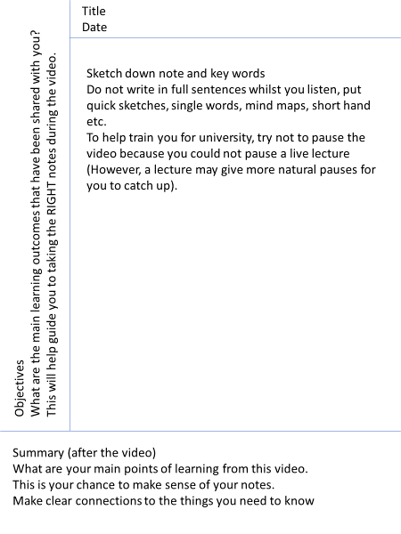

Objectives: | Title:  Date:
Summary:

Objectives: | Title:  Date:
Summary:

Commissioned by The PiXL Club Ltd.

This resource is strictly for the use of member schools for as long as they remain members of The PiXL Club. It may not be copied, sold, or transferred to a third party or used by the school after membership ceases. Until such time it may be freely used within the member school.

All opinions and contributions are those of the authors. The contents of this resource are not connected with, or endorsed by, any other company, organisation or institution.

PiXL Club Ltd endeavour to trace and contact copyright owners. If there are any inadvertent omissions or errors in the acknowledgements or usage, this is unintended and PiXL will remedy these on written notification.

