PiXL Independence:

GCSE Biology – Student Booklet

KS4

Topic: Photosynthesis

Contents:
- Level 1- Multiple Choice Quiz – 20 credits
- Level 2 - 5 questions, 5 sentences, 5 words – 10 credits each
- Level 3 - Science in The News – 100 credits
- Level 4 - Scientific Poster – 100 credits
- Level 5 - Video summaries – 50 credits each

PiXL Independence – Level 1
Multiple Choice Questions
GCSE Biology – Photosynthesis
INSTRUCTIONS Score: /20

- Read the question carefully.
- Circle the correct letter.
- Answer all questions

1. | The correct equation for photosynthesis is:
 | a. | Carbon dioxide + water light + energy
 | b. | Carbon dioxide + water glucose + oxygen
 | c. | Glucose + oxygen carbon dioxide + water
 | d. | Carbon dioxide + light oxygen + glucose
2. | Which of the following statements is NOT true?
 | a. | Green plants and algae can both carry out photosynthesis
 | b. | Light energy is absorbed by a green substance called chloroplasts, which is found in chlorophyll
 | c. | Light energy is used converting carbon dioxide (from the air) and water (from the soil) into glucose
 | d. | Oxygen is released as a by-product of photosynthesis
3. | The rate of photosynthesis may be limited by:
 | a. | Light, water and carbon dioxide
 | b. | Light, water and temperature
 | c. | Light, temperature and carbon dioxide
 | d. | Temperature, water and carbon dioxide
4. | What is the glucose produced in photosynthesis NOT used for?
 | a. | Respiration
 | b. | Producing starch, fat or oil for storage
 | c. | Producing cellulose and proteins
 | d. | Growth and producing new cells
5. | In variegated leaves, the pale areas:
 | a. | Contain chloroplasts and therefore contain starch
 | b. | Contain no chloroplasts and therefore contain starch
 | c. | Contain chloroplasts and therefore contain no starch
 | d. | Contain chlorophyll and therefore contain no starch
6. | When testing cells using iodine:
 | a. | Photosynthetic cells will appear black/blue due to the presence of starch
 | b. | Photosynthetic cells will appear brown due to the presence of starch
 | c. | Cells that do not photosynthesise will appear black/blue due to the presence of glucose
 | d. | Cells that do not photosynthesise will appear brown due to the presence of glucose
7. | Plants gain most of their biomass from:
 | a. | Water
 | b. | Nitrates from the soil
 | c. | Carbon dioxide and water
 | d. | Water and soil
8. | Which is the correct symbol equation for photosynthesis?
 | a. | H₂O + CO₂ O₂ + C₆H₁₂O₆
 | b. | CO₂ + O₂ C₆H₁₂O₆ + CO₂
 | c. | O₂ + C₆H₁₂O₆ CO₂ + H₂0
 | d. | CO₂ + H₂0₂ C₆H₁₂O₆ + O₂
9. | A plant exposed to high temperatures may die. Which of the following is NOT a reason this may occur?
 | a. | Carbon dioxide is unreactive at high temperatures
 | b. | The plant will wilt and not trap light energy
 | c. | Enzymes within the plant may denature
 | d. | Evaporation may cause rapid water loss via the stomata
10. | Which statement correctly describes photosynthesis?
 | a. | Photosynthesis is an exothermic reaction as light is transferred from the environment to the chloroplasts by heat.
 | b. | Photosynthesis is an endothermic reaction as light is transferred from the environment to chloroplasts by light.
 | c. | Photosynthesis is an energy neutral reaction as 100% light energy is converted into a chemical store of energy.
 | d. | Photosynthesis is an exergonic reaction as there is exergonic due to the change in the Gibbs free energy.
11. | Which statement is NOT a reason that plants convert sugars to starch?
 | a. | Starch can be converted back into glucose
 | b. | Starch does not affect the water concentration inside cells
 | c. | Starch is insoluble and so will not flow out of cells
 | d. | Starch provides strength to the cell wall
12. | Why do plants convert glucose into sucrose?
 | a. | Sucrose is stored in fruits and tastes sweeter than glucose
 | b. | Sucrose is insoluble so it can be stored inside the cells
 | c. | Sucrose dissolves in water and flows easily
 | d. | Sucrose can’t be converted back into glucose
13. | What do plants need to add to glucose in order to form proteins?
 | a. | Carbon dioxide from the air
 | b. | Water from the soil
 | c. | Nitrates from the soil
 | d. | Light energy from the Sun
14. | Leaves of plants found in bright sunlight tend to have more stomata because…
 | a. | The leaves need to take in more sunlight
 | b. | The leaves need to take in more water
 | c. | The leaves need to remove more carbon dioxide
 | d. | The leaves need to take in more carbon dioxide
15. | Many commercial greenhouses use heaters that burn gas or oil because…
 | a. | It increases the temperature of the greenhouse
 | b. | It increases the light inside the greenhouse
 | c. | It increases the amount of oxygen inside the greenhouse
 | d. | It increases the amount of carbon dioxide and heat inside the greenhouse
16. | Controlling water supply is one way commercial growers can increase crop production. Sensors are used to detect how dry the soil is. Which of the following is NOT a reason for a business to use an automated system?
 | a. | Too much water can cause rotting
 | b. | Setting up an automated system is expensive
 | c. | Plants have a constant supply of water
 | d. | Fewer people are needed
17. | Water enters the plant…
 | a. | Through the leaves via diffusion
 | b. | Through the roots via active transport
 | c. | Through the roots via osmosis
 | d. | Through the leaves via transpiration
18. | Diffusion is…
 | a. | Movement of molecules from a high to a low concentration down a concentration gradient
 | b. | Movement of molecules from a high to a low concentration up a concentration gradient
 | c. | Using energy to move molecules against their concentration gradient
 | d. | When water moves from a concentrate to a dilute solution across a cell membrane
19. | Not all of the sunlight landing on a plant is converted into glucose. Which of the following statements is NOT true?
 | a. | Some of the light is reflected back off the surface of the leaf
 | b. | Some of the light is converted into hear energy by the plant
 | c. | Some of the light falls on parts that do not photosynthesise
 | d. | Some of the light is transmitted through the plant
20. | Which of the following graphs correctly describes the relationship between temperature and the rate of photosynthesis?
 | a.
 | b.
 | c.
 | d. | 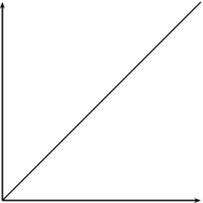

PiXL Independence – Level 2
5 questions, 5 sentences, 5 words
GCSE Biology – Photosynthesis
INSTRUCTIONS

- For each statement, use either the suggested website or your own text book to write a 5-point summary. In examinations, answers frequently require more than 1 key word for the mark, so aim to include a few key words.
- It is important to stick to 5 sentences. It is the process of selecting the most relevant information and summarising it, that will help you remember it.
- Write concisely and do not elaborate unnecessarily, it is harder to remember and revise facts from a big long paragraph.
- Finally, identify 5 key words that you may have difficulty remembering and include a brief definition. You might like to include a clip art style picture to help you remember it.

Example:
QUESTION: | How does photosynthesis take place in plants?
Sources: | Website – http://www.s-cool.co.uk/gcse/biology/photosynthesis/revise-it/photosynthesis  Animation - www.saps.org.uk/secondary/themes/1281
- Photosynthesis uses carbon dioxide and water to generate glucose and oxygen.
- Carbon dioxide and oxygen move in and out of the leaf, through stomata, via diffusion.
- Photosynthesis takes place in the palisade mesophyll where the cells have a high concentration of chloroplasts.
- Water enters the plants through the roots via osmosis and is transported to the leaves through the xylem.
- Light from the visible spectrum is used to provide the energy for this reaction to take place.
Photosynthesis |  | Light energy | Chloroplasts | Carbon dioxide + water | Glucose + Oxygen

QUESTION 1: | How does light intensity effect photosynthesis?
Sources: | Website – www.nuffieldfoundation.org/practical-biology/investigating-factors-affecting-rate-photosynthesis  Interactive - www.reading.ac.uk/virtualexperiments/ves/preloader-photosynthesis-full.html

QUESTION 2: | What do plants, and some algae, do with glucose made during photosynthesis?
Sources: | Website – www.bbc.co.uk/schools/gcsebitesize/science/add_aqa/photosynthesis/photosynthesisrev4.shtml  Interactive - www.indiana.edu/~oso/animations/potato.swf

QUESTION 3: | What can limit the rate of photosynthesis?
Sources: | Website – http://ib.bioninja.com.au/standard-level/topic-2-molecular-biology/29-photosynthesis/limiting-factors.html  Video - www.youtube.com/watch?v=xEhvsXG8cNs

QUESTION 4: | How do plants help reduce climate change?
Sources: | Website – www.bbc.co.uk/news/science-environment-14121360  Interactive - https://svs.gsfc.nasa.gov/10494

QUESTION 5: | Can biofuels reduce our impact on the environment?
Sources: | Website – www.theguardian.com/environment/2017/jul/14/biofuels-need-to-be-improved-for-battle-against-climate-change  Interactive - www.nationalgeographic.org/video/edu-bio-fuels/

PiXL Independence – Level 3
Science in the News
GCSE Biology – Photosynthesis
INSTRUCTIONS

Fake news
Sensationalised news stories have been around for some time, but with the mass growth of social media, the problem seems to have grown in recent years. At the very least, the US Presidential election has certainly highlighted the impact that misleading information can have. www.tiny.cc/fakenews2
At home, the Brexit vote also suffered from the circulation of misleading news stories www.tiny.cc/fakenews3
Therefore, the ability to identify real information, track it back to the source article and make your own judgement is a very important skill. This activity will help you develop that skill.

Do Houseplants Improve Air Quality?
News article http://www.refinery29.uk/air-purifying-plants
WHO article http://www.who.int/mediacentre/factsheets/fs292/en/
Discussion article http://www.gardenmyths.com/garden-myth-born-plants-dont-purify-air/
Real article https://ia800300.us.archive.org/35/items/nasa_techdoc_19930072988/19930072988.pdf

Task 1:
You need to produce a 1 page essay on the question “Do plants reduce air pollution?”

Essay section | Activity
Introduction | Outline plants ability to exchange gases with the atmosphere and why scientists think this could be of benefit to us.
Describe | Describe some of the common pollution or causes of pollution in homes and some of the health risks associated with these.
Explore | Explore which plants are most effective at reducing air pollution and what types of pollution can be reduced.
Evaluate | Evaluate whether this is a suitable method to reducing pollution and how reliable this evidence base is.

Photosynthesis and Energy Transfer in Food Chains
News article https://www.theguardian.com/environment/2015/oct/13/agriculture-farming-food-addiction-meat-harvest-hungry-world
NHS article http://www.nhs.uk/Livewell/Vegetarianhealth/pages/Vegetarianhealthqanda.aspx
Discussion article http://www.bbc.com/future/story/20160926-what-would-happen-if-the-world-suddenly-went-vegetarian
Real article http://people.umass.edu/bethanyb/GCE/McMichael%20et%20al.%2C%202007.pdf
Task 2:
You need to produce a 1 page essay on “A vegetarian diet is a more efficient way of feeding the world population”

Essay section | Activity
Introduction | Summarise how all life on Earth is dependent on the Sun.
Describe | Describe how energy enters a food chain and how it is passed from producer to consumers. Describe how energy is lost from a food chain and how increasing the length of a food chain decreases its efficiency.
Explore | Explore the costs and benefits of modern agricultural techniques including intensive farming. Explore how vegetarian or vegan diets would reduce some of these impacts.
Evaluate | Evaluate the benefits to individuals, to the global community and to habitats and ecosystems on Earth of people adopting a vegetarian or vegan diet.

PiXL Independence – Level 4
Scientific Posters
GCSE Biology – Photosynthesis

INSTRUCTIONS

Scientific Posters
Scientists communicate research findings in three main ways. Primarily, they write journal articles much like an experiment write up. These are very concise, appraise the current literature on the problem and present findings. Scientists then share findings at conferences through talks and scientific posters. During a science degree, you would practice all three of these skills.

Scientific posters are a fine balance between being graphically interesting and attracting attention and sharing just the right amount of text to convey a detailed scientific message. They are more detailed than a talk and less detailed than a paper.
Use this information to help structure your poster – www.tiny.cc/posterskills (that’s Poster Skills not Posters Kill!) More detailed guidance is available at: www.tiny.cc/posterskills2

Creating your poster
It is easiest to create a poster in PowerPoint; however, you need to add custom text boxes rather than using the standard templates.
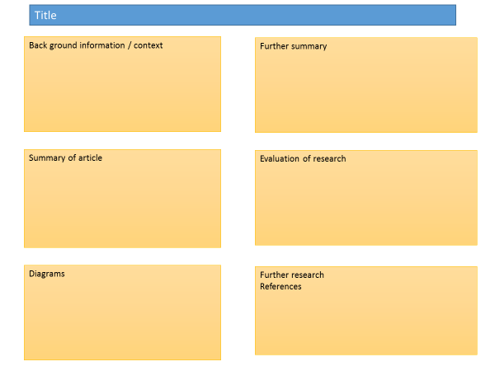
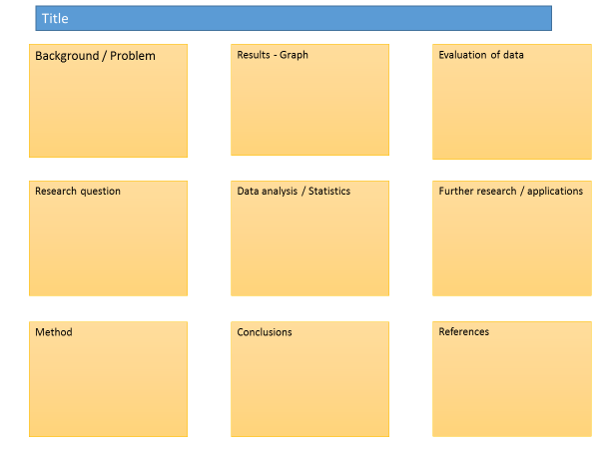

Posters need to be eye catching, but readable from a distance. If you use PowerPoint, start with a 4:3 slide (for easier printing, it can then be printed on A3) and use a 14-16 pt font. The first box could be larger to draw people in. You can use a background image, but pick a simple one that is of high quality. Select text box fill and select change the transparency to maintain the contrast and partially show the picture.
You can experiment with different layouts and you should include images. Avoid a chaotic layout, posters are read from top left column downwards.
Remember to include the authors and references.
Finally, look at the examples given on the University of Texas website which also offers an evaluation of each www.tinyurl.com/postereg

Maximising Photosynthesis

Background
Photosynthesis requires light, carbon dioxide and water. If the supply of these to the plant are limited in anyway then photosynthesis does not take place at its maximum rate.
A challenge for commercial growers, farms and nurseries is to provide plants with the right conditions for photosynthesis to take place. This will optimise growth and potentially increase their profits.

Source articles
http://www.rsc.org/learn-chemistry/content/filerepository/CMP/00/001/068/Rate%20of%20photosynthesis%20limiting%20factors.pdf

http://gpnmag.com/wp-content/uploads/12_TechnicallySpeaking_GPN1212%20FINAL.pdf

http://www.saps.org.uk/secondary/teaching-resources/800-video-commercial-growers

http://www1.agric.gov.ab.ca/$department/deptdocs.nsf/all/opp2902

Use other sources as necessary.

Task:
Produce a scientific poster on “How commercial growers maximise productivity”

Recall | State the equation for photosynthesis and identify factors that can limit the rate of photosynthesis
Describe | Describe, using graphs where appropriate, the effect of limiting factors on the rate of photosynthesis.
Compare | Compare the different ways commercial growers can increase productivity by ensuring there are no limiting factors.
Evaluate | Evaluate different ways of increasing photosynthesis and therefore crop production, including which is the most cost-effective method.

PiXL Independence – Level 5
Video summaries
GCSE Biology – Photosynthesis

Cornell Notes
At A level and University, you will make large amounts of notes, but those notes are only of use if you record them in a sensible way. One system for recording notes is known as the Cornell notes system. This method encourages you to select relevant information, rather than trying to write a transcript of everything said. More importantly, it forces you to spend a few minutes reviewing what you have written, which has been scientifically proven to aid learning and memory retention.
The ideal is to write everything on one page, but some students may prefer to type and others will to handwrite their notes. Whichever option you use, remember the aim is to summarise and condense the content with a focus on the objectives that you are trying to learn and understand.

There are three main sections to the Cornell notes
- Cue/ Objectives – This can be done before or after the lecture. You may have been provided with the objectives or you may need to decide what they were (in a less well-structured lecture) or you may want to make the link to your learning if this is an additional task or lecture you are viewing, such as this video.
- Notes – In this space you record concisely, simply the things you really will not remember. The NEW knowledge.
- Summary – the most important step that is carried out after the lecture. This helps to reinforce learning.

Background
The following short TED talks present two topics that link to your learning. The first discusses artificial photosynthesis. The second video discusses an application of science which leads to cheap renewable fuel production using photosynthesis.

Source article:
Ted Ed talks https://www.youtube.com/watch?v=pgRKCHZ0gQA
Jenny Zhang works on developing the basic science behind artificial photosynthesis by combining natural bio-catalysts with earth-abundant metal oxides which would help to develop the use of hydrogen as a sustainable green fuel of the future.

Ted Ed talks https://www.youtube.com/watch?v=bhH3_EY6uq8
Adam Hill explains the benefits of artificial photosynthesis – developing man-made materials that mimic the behavior of plants – including converting solar energy into chemical fuels.

Task:

You need to produce a set of Cornell notes for the video given above.
Use the following objective to guide your note taking, this links to your learning.

- Discuss the benefits of artificial photosynthesis.
- Discuss the challenges that this technology faces and why it is not yet ready to be used world-wide.

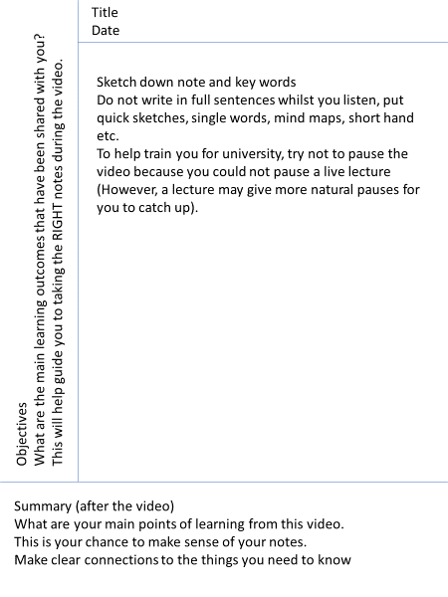

Objectives: | Title:  Date:
Summary:

Objectives: | Title:  Date:
Summary:

Commissioned by The PiXL Club Ltd.

This resource is strictly for the use of member schools for as long as they remain members of The PiXL Club. It may not be copied, sold, or transferred to a third party or used by the school after membership ceases. Until such time it may be freely used within the member school.

All opinions and contributions are those of the authors. The contents of this resource are not connected with, or endorsed by, any other company, organisation or institution.

PiXL Club Ltd endeavour to trace and contact copyright owners. If there are any inadvertent omissions or errors in the acknowledgements or usage, this is unintended and PiXL will remedy these on written notification.

