PiXL Independence:

GCSE Biology – Student Booklet

KS4

Topic: Ecosystems

Contents:
- Level 1- Multiple Choice Quiz – 20 credits
- Level 2 - 5 questions, 5 sentences, 5 words – 10 credits each
- Level 3 - Science in The News – 100 credits
- Level 4 - Scientific Poster – 100 credits
- Level 5 - Video summaries – 50 credits each

PiXL Independence – Level 1
Multiple Choice Questions
GCSE Biology – Ecosystems
INSTRUCTIONS Score: /20

- Read the question carefully.
- Circle the correct letter.
- Answer all questions

1. | Materials are continually recycled in the living world.  Which of these is NOT a method of material cycling?
 | a. | Photosynthesis
 | b. | Respiration
 | c. | Decomposition
 | d. | Classification
2. | An ecosystem is…
 | a. | the interaction of a community of living organisms and the non-living parts of the environment.
 | b. | the factors in a habitat that affect an organism.
 | c. | all the members of one species in a habitat at one time.
 | d. | the geographical area occupied.
3. | Which of the following resources do plants NOT compete for?
 | a. | Water and minerals
 | b. | Mates
 | c. | Light
 | d. | Space
4. | Within a community, species depend on one another for food, shelter, pollination etc. This is known as:
 | a. | Dependent variable
 | b. | Codependence
 | c. | Interdependence
 | d. | Interbreeding
5. | When is a community stable?
 | a. | When all species and environment factors balance
 | b. | When some species are increasing their population size
 | c. | When all species are increasing their population size
 | d. | When one species is removed from the habitat.
6. | Which of the following is NOT an abiotic factor?
 | a. | Light intensity
 | b. | Carbon dioxide levels for plants
 | c. | Oxygen levels for aquatic animals
 | d. | Introduction of predators
7. | Occasionally one species will outcompete another so that the numbers remaining are no longer sufficient to breed. This is an example of a:
 | a. | Selection pressure
 | b. | Biotic factor
 | c. | Population pressure
 | d. | Abiotic factor
8. | What does the term ‘mutualism’ mean?
 | a. | Organisms that live on or in a host; the host suffers.
 | b. | Leguminous plants.
 | c. | Organisms that live together, both species benefit.
 | d. | Conservation of a species.
9. | Bacteria living in deep sea vents are called:
 | a. | Aquatic
 | b. | Xerophytes
 | c. | Extremophiles
 | d. | Hydrophillic
10. | All the biomass on Earth originates via the process of:
 | a. | Respiration
 | b. | Combustion
 | c. | Decomposition
 | d. | Photosynthesis
11. | In a food chain, synthesis of molecules is carried out by…
 | a. | Producers
 | b. | Consumers
 | c. | Heterotrophs
 | d. | Synesthetics
12. | Ecologists might use which pieces of equipment to determine distribution and abundance of a species?
 | a. | Abundancometer and distributometer
 | b. | Transept and quadruped
 | c. | Transect and quadrat
 | d. | Triceps and quadriceps
13. | Which is the correct definition for the term ‘mean’?
 | a. | the largest number in a data set, divided by the total number of terms in the set
 | b. | the number which appears most often in a set of numbers
 | c. | the value separating the higher half of a data sample, a population, or a probability distribution, from the lower half
 | d. | the average of a set of numerical values, as calculated by adding them together and dividing by the number of terms in the set
14. | Which gives the correct order of organisms in a food chain?
 | a. | Producer secondary consumer tertiary consumer primary consumer
 | b. | Tertiary consumer secondary consumer primary consumer producer
 | c. | Producer primary consumer secondary consumer tertiary consumer
 | d. | Primary consumer secondary consumer tertiary consumer producer
15. | Which of the following is NOT a true statement about the carbon cycle?
 | a. | Photosynthesis uses CO₂
 | b. | Respiration release CO₂
 | c. | Combustion uses CO₂
 | d. | Burning fossil fuels releases CO₂
16. | Which combination of factors would slow down decomposition?
 | a. | Low temperature, low water, low oxygen
 | b. | Low carbon dioxide, low temperature, low oxygen
 | c. | High temperature, high water, high oxygen
 | d. | Low water, high carbon dioxide, low oxygen
17. | Why can anaerobic decay be useful?
 | a. | Carbon dioxide is released back into the carbon cycle
 | b. | Water precipitates back into the water cycle
 | c. | Hydrogen gas is release which can be used in fuel cells
 | d. | Methane gas is released which can be used as a fuel
18. | Organisms are adapted to survive in the conditions in which they normally live. Which of the following is NOT a way that an organism adapts?
 | a. | Pyschological
 | b. | Structural
 | c. | Behavioural
 | d. | Functional
19. | In the water cycle, fresh water is moved through the environment by which two processes?
 | a. | Precipitation and combustion
 | b. | Condensation and precipitation
 | c. | Evaporation and precipitation
 | d. | Decomposition and evaporation
20. | Decay of waste biological material is:
 | a. | A major contributor to global warming
 | b. | Causing an imbalance in the carbon cycle
 | c. | A source if natural fertilizer for garden plants or crops
 | d. | Damaging the environment due to landfill

PiXL Independence – Level 2
5 questions, 5 sentences, 5 words
GCSE Biology – Ecosystems
INSTRUCTIONS

- For each statement, use either the suggested website or your own text book to write a 5-point summary. In examinations, answers frequently require more than 1 key word for the mark, so aim to include a few key words.
- It is important to stick to 5 sentences. It is the process of selecting the most relevant information and summarising it, that will help you remember it.
- Write concisely and do not elaborate unnecessarily, it is harder to remember and revise facts from a big long paragraph.
- Finally, identify 5 key words that you may have difficulty remembering and include a brief definition. You might like to include a clip art style picture to help you remember it.

Example:
QUESTION: | Describe the features of a community
Sources: | Website – www.s-cool.co.uk/a-level/biology/ecological-concepts/revise-it/the-concept-of-the-ecosystem  Video - www.youtube.com/watch?v=RBOsqmBQBQk
- An ecosystem is the interaction of a community of living organisms (biotic) with the non-living (abiotic) parts of their environment.
- To survive and reproduce, organisms require a supply of materials from their surroundings and from the other living organisms there.
- Plants in a community or habitat often compete with each other for light and space, and for water and mineral ions from the soil. Animals often compete with each other for food, mates and territory.
- Within a community each species depends on other species for food, shelter, pollination, seed dispersal etc. If one species is removed it can affect the whole community.
- A stable community is one where all the species and environmental factors are in balance so that population sizes remain fairly constant.
Ecosystem |  | Survive | Competition | Community | Biotic/Abiotic factors

QUESTION 1: | How could the population size of daisies in trampled and un-trampled parts of a school field be investigated?
Sources: | Website – www.nuffieldfoundation.org/practical-biology/biodiversity-your-backyard  Interactive - www.saps.org.uk/secondary/teaching-resources/258-ecology-practical-1-measuring-abundance-and-random-sampling

QUESTION 2: | Describe how carbon is cycled through plants, animals and the atmosphere.
Sources: | Website – www.khanacademy.org/science/biology/ecology/biogeochemical-cycles/a/the-carbon-cycle  Interactive - www.sciencelearn.org.nz/image_maps/3-carbon-cycle

QUESTION 3: | Describe how water is continually cycled through the environment and living organisms.
Sources: | Website – www.gcsescience.com/w1-water-cycle.htm  Video - www.youtube.com/watch?v=al-do-HGuIk

QUESTION 4: | Explain decomposition including how why it is important for life on Earth and how its rate can be increased.
Sources: | Website – www.s-cool.co.uk/gcse/biology/environment/revise-it/cycling-through-nature  Video - www.youtube.com/watch?v=FVrOIMmmBQE

QUESTION 5: | Describe how to investigate the effect of temperature on the rate of decay of fresh milk by measuring the pH change.
Sources: | Website – www.nuffieldfoundation.org/practical-biology/investigating-effect-temperature-activity-lipase  Video - www.youtube.com/watch?v=8Yqbu56ImXk

PiXL Independence – Level 3
Science in the News
GCSE Biology – Ecosystems
INSTRUCTIONS

Fake news
Sensationalised news stories have been around for some time, but with the mass growth of social media, the problem seems to have grown in recent years. At the very least, the US Presidential election has certainly highlighted the impact that misleading information can have. www.tiny.cc/fakenews2
At home, the Brexit vote also suffered from the circulation of misleading news stories www.tiny.cc/fakenews3
Therefore, the ability to identify real information, track it back to the source article and make your own judgement is a very important skill. This activity will help you develop that skill.

Killer Hornets
News article www.express.co.uk/news/nature/793278/hornet-asian-giant-killer-wasps-uk-invasion-sting
British association article www.bbka.org.uk/help/asian_hornet
Discussion article https://www2.warwick.ac.uk/newsandevents/pressreleases/asian_hornet_147adds/
Real article www.nonnativespecies.org/factsheet/factsheet.cfm?speciesId=3826 (make sure to use the articles on the side bar menu also)

Task 1:
You need to produce a 1 page essay on “The Invasion of the Killer Hornet”

Essay section | Activity
Introduction | What is the “Killer Hornet”? How does it differ to native species? When it was first identified in the UK?
Describe | Describe the invasion of the Asian hornet and the threat it poses to native species in the UK.
Explore | Explore the potential risks to people and wildlife in the UK and whether the Asian hornet offers any benefit to habitats and ecosystems.
Evaluate | Evaluate whether we should do anything to prevent the further spread of the Asian hornet throughout the UK.

Beavers Running Wild in the UK
News article www.bbc.co.uk/news/uk-england-devon-40503901
RSPB article https://ww2.rspb.org.uk/our-work/our-positions-and-casework/our-positions/species/beaver-reintroduction-in-the-uk
Discussion article www.wildlifetrusts.org/why-bring-back
Real article www.newscientist.com/article/dn28488-should-the-uk-bring-back-beavers-to-help-manage-floods/

Task 2:
You need to produce a 1 page essay on “Beavers Running Wild in the UK”

Essay section | Activity
Introduction | Outline the timescale and geography of extinction and reintroduction of the Eurasian beaver to the UK
Describe | Describe the reasons for the extinction of beavers and how its reintroduction could impact on food chains, competition and habitats in the UK.
Explore | Explore the arguments for and against, whether reintroduction should be limited to specific areas and what benefits this might offer.
Evaluate | Evaluate the reintroduction of the Eurasian beaver weighing up the costs and benefits and suggesting any future advantages or problems might arise and how these might be investigated.

PiXL Independence – Level 4
Scientific Posters
GCSE Biology – Ecosystems
INSTRUCTIONS

Scientific Posters
Scientists communicate research findings in three main ways. Primarily, they write journal articles much like an experiment write up. These are very concise, appraise the current literature on the problem and present findings. Scientists then share findings at conferences through talks and scientific posters. During a science degree, you would practice all three of these skills.

Scientific posters are a fine balance between being graphically interesting and attracting attention and sharing just the right amount of text to convey a detailed scientific message. They are more detailed than a talk and less detailed than a paper.
Use this information to help structure your poster – www.tiny.cc/posterskills (that’s Poster Skills not Posters Kill!) More detailed guidance is available at: www.tiny.cc/posterskills2

Creating your poster
It is easiest to create a poster in PowerPoint; however, you need to add custom text boxes rather than using the standard templates.
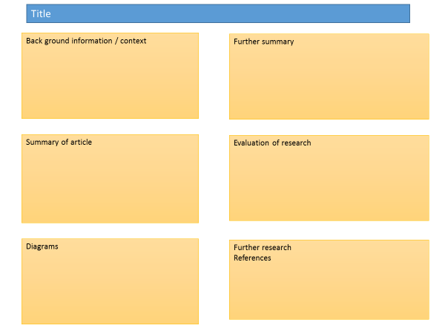
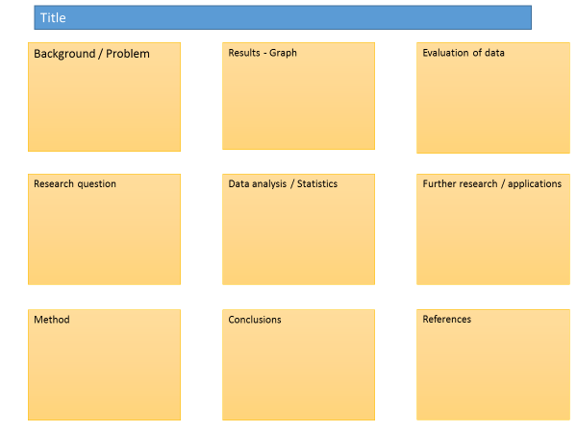

Posters need to be eye catching, but readable from a distance. If you use PowerPoint, start with a 4:3 slide (for easier printing, it can then be printed on A3) and use a 14-16 pt font. The first box could be larger to draw people in. You can use a background image, but pick a simple one that is of high quality. Select text box fill and select change the transparency to maintain the contrast and partially show the picture.
You can experiment with different layouts and you should include images. Avoid a chaotic layout, posters are read from top left column downwards.
Remember to include the authors and references.
Finally, look at the examples given on the University of Texas website which also offers an evaluation of each www.tinyurl.com/postereg

The Decline of the Atlantic Puffin?

Background
Scientists are concerned about the falling number of puffins both in our country and globally; in Iceland there has been a loss of 2 million breeding pairs, equivalent to a 40% fall in the population since 2003. There are a number of possible causes for this change including biotic and abiotic factors. In order to prevent this decline further, scientists needs to understand the nature of this change and collect data on population sizes as well as any changes in biotic and abiotic factors.

Source articles
www.rspb.org.uk/birds-and-wildlife/bird-and-wildlife-guides/bird-a-z/p/puffin/
www.rspb.org.uk/birds-and-wildlife/bird-and-wildlife-guides/bird-a-z/p/puffin/population_conservation.aspx
www.rspb.org.uk/community/getinvolved/b/seabirds/archive/2017/03/22/atlantic-puffin-at-the-crossroads-terminal-decline-or-a-cyclical-slump.aspx
http://journals.plos.org/plosone/article?id=10.1371/journal.pone.0131527

Use other sources as necessary.

Task:
Produce a scientific poster on “The decline of the Atlantic Puffin?”

Recall | Define the terms ‘abiotic factors’ and ‘biotic factors’. Identify which factors might impact upon the puffin population.
Describe | Describe the puffin’s normal habitat, breeding and migratory habits and diet. Describe how this is changing.
Compare | Compare the decrease in the puffin population to the changes in abiotic and biotic factors including the sand eel population
Evaluate | Evaluate the strength of the data. Is it reliable? Accurate? What further information is required to make informed decisions?

PiXL Independence – Level 5
Video summaries
GCSE Biology – Ecosystems

Cornell Notes
At A level and University, you will make large amounts of notes, but those notes are only of use if you record them in a sensible way. One system for recording notes is known as the Cornell notes system. This method encourages you to select relevant information, rather than trying to write a transcript of everything said. More importantly, it forces you to spend a few minutes reviewing what you have written, which has been scientifically proven to aid learning and memory retention.
The ideal is to write everything on one page, but some students may prefer to type and others will to handwrite their notes. Whichever option you use, remember the aim is to summarise and condense the content with a focus on the objectives that you are trying to learn and understand.

There are three main sections to the Cornell notes
- Cue/ Objectives – This can be done before or after the lecture. You may have been provided with the objectives or you may need to decide what they were (in a less well-structured lecture) or you may want to make the link to your learning if this is an additional task or lecture you are viewing, such as this video.
- Notes – In this space you record concisely, simply the things you really will not remember. The NEW knowledge.
- Summary – the most important step that is carried out after the lecture. This helps to reinforce learning.

Background
The following short TED talks present two topics that link to your learning. Ecosystems and communities of plants and animals support human life in Earth. In order to continue to benefit from these humans need to engage with the environment in a sustainable way. These videos explore how humans are threatening biodiversity as well as the natural systems that support it and consider actions we need to take to ensure our future health, prosperity and well-being.

Source article:
Ted Ed talks: www.ted.com/talks/pavan_sukhdev_what_s_the_price_of_nature

Ted Ed talks: www.ted.com/talks/jonathan_foley_the_other_inconvenient_truth

Task:

You need to produce a set of Cornell notes for the video given above.
Use the following objective to guide your note taking, this links to your learning.

- Discuss the challenges of maintaining biodiversity on Earth.
- Discuss how maintaining biodiversity may conflict with pressures created by a growing human population.

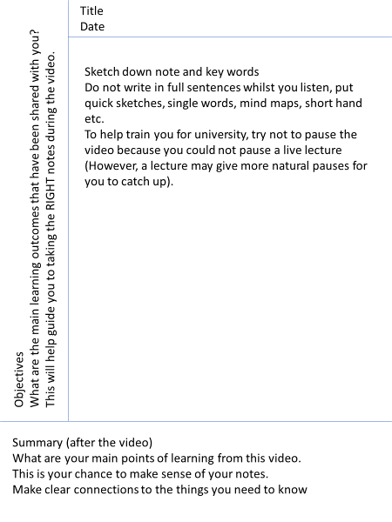

Objectives: | Title:  Date:
Summary:

Objectives: | Title:  Date:
Summary:

Commissioned by The PiXL Club Ltd.

This resource is strictly for the use of member schools for as long as they remain members of The PiXL Club. It may not be copied, sold, or transferred to a third party or used by the school after membership ceases. Until such time it may be freely used within the member school.

All opinions and contributions are those of the authors. The contents of this resource are not connected with, or endorsed by, any other company, organisation or institution.

PiXL Club Ltd endeavour to trace and contact copyright owners. If there are any inadvertent omissions or errors in the acknowledgements or usage, this is unintended and PiXL will remedy these on written notification.

